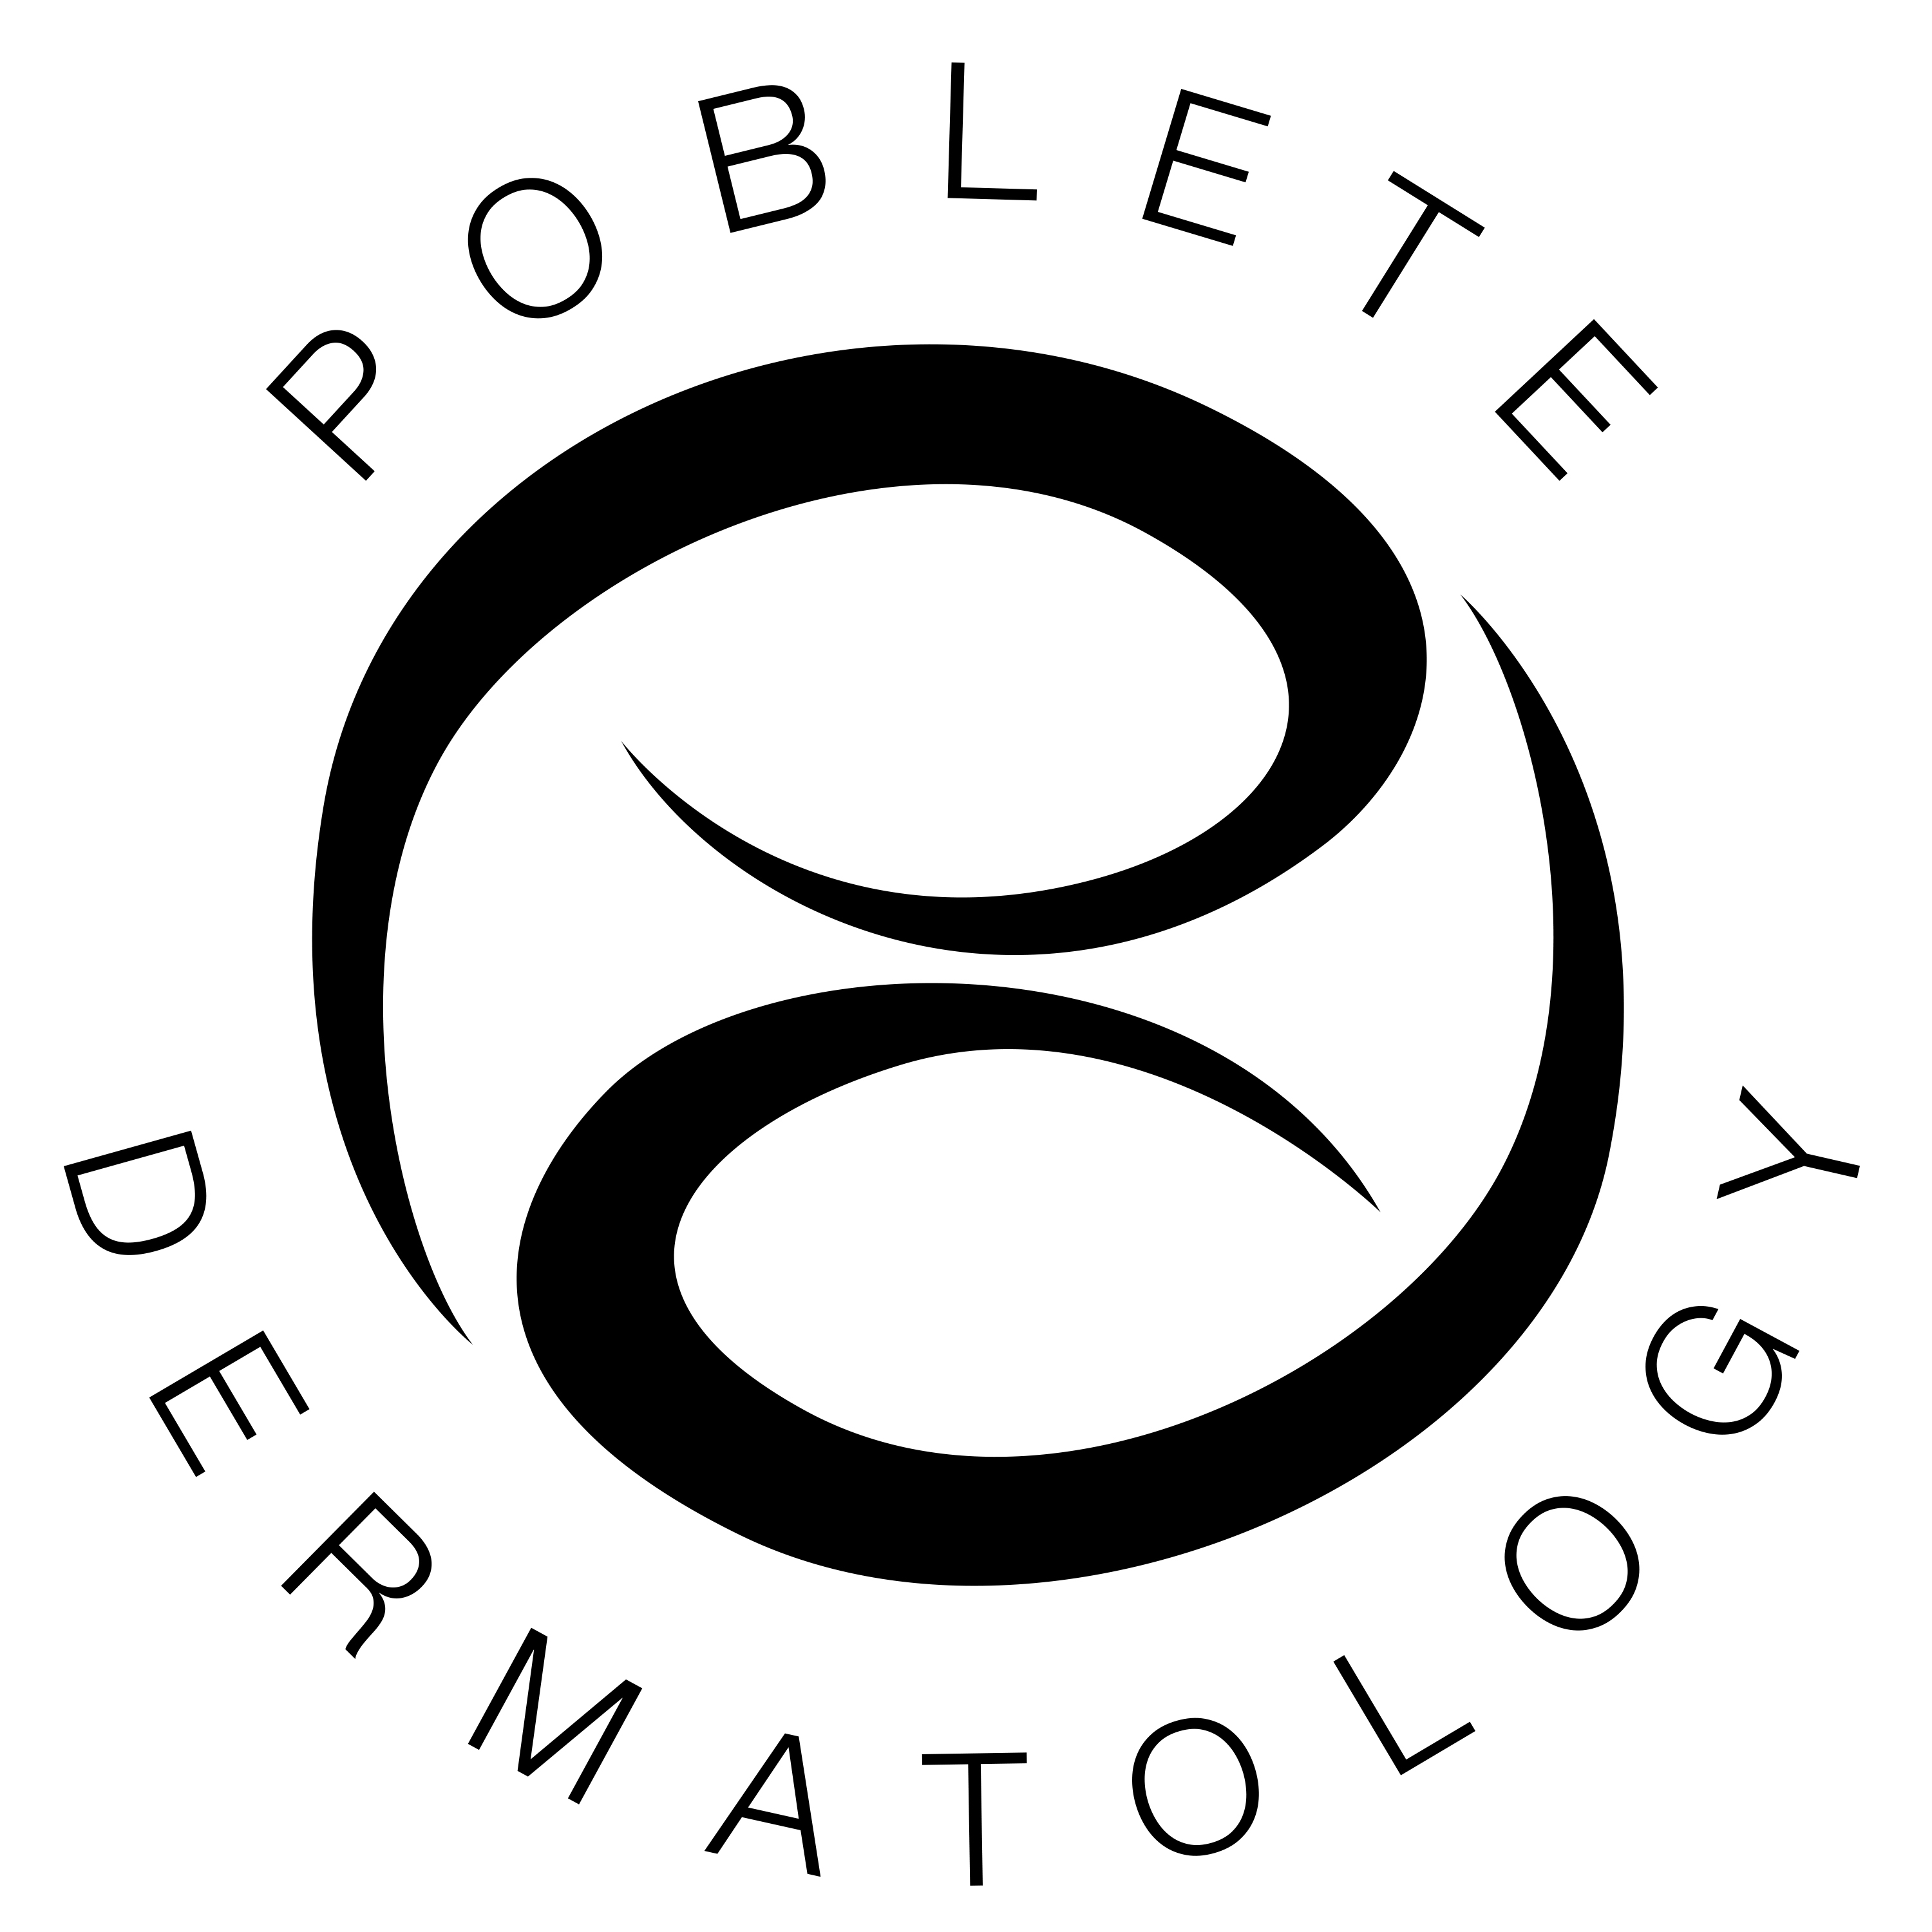

Notice of Privacy Policies and Practice for Poblete Dermatology, LLC

THIS NOTICE DESCRIBES HOW MEDICAL INFORMATION ABOUT YOU MAY BE USED AND DISCLOSED AND HOW YOU CAN GET ACCESS TO THIS INFORMATION. PLEASE READ IT CAREFULLY.

The Health Insurance Portability & Accountability Act of 1996 (HIPAA) is a Federal program that requests that all medical records and other individually identifiable health information used or disclosed by us in any form, whether electronically, on paper, or orally are kept properly confidential. This act gives you, the patient, the right to understand and control how your protected health information (PHI) is used. HIPAA provides penalties for covered entities that misuse personal health information.
As required by HIPAA, we prepared this explanation of how we are to maintain the privacy of your health information and how we may disclose your personal information.
We may use and disclose your medical records only for each of the following purposes: treatment, payment and health care operation.
- Treatment means providing, coordinating, or managing health care and related services by one or more healthcare providers. An example of this is a primary care doctor referring you to a specialist doctor.
- Payment means such activities as obtaining reimbursement for services, confirming coverage, billing or collections activities, and utilization review. An example of this would include sending your insurance company a bill for your visit and/or verifying coverage prior to a surgery.
- Health Care Operations include business aspects of running our practice, such as conducting quality assessments and improving activities, auditing functions, cost management analysis, and customer service. For example, information on the services you received may be used to support budgeting and financial reporting, and activities to evaluate and promote quality. We will share your PHI with other persons or entities who perform various activities for our practice. These business associates will also be required to protect your health information.
- The practice may also be required or permitted to disclose your PHI for law enforcement and other legitimate public health reasons. In all situations, we shall do our best to assure its continued confidentiality to the extent possible. We may also create and distribute de-identified health information by removing all reference to individually identifiable information. We may contact you, by phone or in writing, to provide appointment reminders or information about treatment alternatives or other health- related benefits and services that may be of interest to you. The following use and disclosures of PHI will only be made pursuant to us receiving a written authorization from you:
  - Uses and disclosure of your PHI for marketing purposes, including subsidized treatment and health care operations;
  - Disclosures that constitute a sale of PHI under HIPAA; and
  - Other uses and disclosures not described in this notice. You may revoke such authorization in writing and we are required to honor and abide by that written request, except to the extent that we have already taken actions relying on your prior authorization. You may have the following rights with respect to your PHI:
- The right to request restrictions on certain uses and disclosures of PHI, including disclosures to family members, other relatives, close personal friends, or any other person identified by you. We are, however, not required to honor a request restriction except in limited circumstances which we shall explain if you ask. If we do agree to the restriction, we must abide by it unless you agree in writing to remove it.
- The right to reasonable requests to receive confidential communications of Protected Health Information by alternative means or at alternative locations.

Notice of Privacy Policies and Practice for Poblete Dermatology, LLC

- The right to inspect, copy, and receive an accounting of disclosures of your PHI. If you wish to obtain a paper or electronic copy of your PHI, we will provide this copy usually within 30 days of your request and we may charge you a reasonable, cost-based fee.
- The right to amend your PHI. To do so you must fill out a written request. We have the right to deny your request, and will notify you in writing within 60 days.
- The right to be advised if your unprotected PHI is intentionally or unintentionally disclosed. If you have paid for services "out of pocket", in full and in advance, and you request that we not disclose PHI related solely to those services to a health plan, we would accommodate your request, except where we are required by law to make a disclosure. We are required by law to maintain the privacy of your PHI and to provide you the notice of our legal duties and our privacy practice with respect to PHI. This notice is effective as of September 23, 2013 and it is our intention to abide by the terms of the Notice of Privacy Practices and HIPAA Regulations currently in effect. We reserve the right to change the terms of our Notice of Privacy Practice and to make the new notice provision effective for all PHI that we maintain. We will post a copy and you may request a written copy of the revised Notice of Privacy Practice from our office. For more information, contact the Practice Compliance Officer, Tara Strauss, in person or in writing. If you believe that your privacy rights have been violated, you file a formal, written complaint with the practice and with the Office for Civil Rights, U.S. Department of Health and Human Services, Office of Civil Rights. There will be no retaliation against you for filing a complaint.

Payment
We may use and disclose health information about you so that we may bill and receive payment for the treatment and services that you receive. Your information may also be necessary for purposes of determining coverage, medical necessity , pre authorization or certification and for utilization management. The information may be released to an insurance company, third party payer or other entity in the payment of your medical bill and may include copies or portions of your medical record, which are necessary for payment of your account.

Health Care operations
We may use and disclose your health information for our health care operations, including quality assurance, utilization review, medical review, internal auditing, accreditation, social services certification, licensing or credentialing activities.

Appointment Reminders
We may use and disclose your health information to contact you as a reminder that you have an appointment for treatment or medical care.

Persons Involved in Your Care
Unless you object, we may disclose your health information to family members, other relatives, close personal friends or any other person who are involved with your medical care or payment.

Safety of a person or the public
We may use and disclose your health information to prevent or lessen a serious and imminent threat to the health or safety of a person or the public.

Change of this notice

Poblete Dermatology LLC will abide by the terms of this notice currently in effect. However, we reserve the right to change the terms of its notice and to make the new provisions effective for all health information that it maintains.

The effective date of this notice is September 2, 2014.

